**Practice Test Paper**

1) HTML Stands for Hyper text markup Language

2) What is the current version of HTML HTML5

3) IDE Stands for Integrated Develop Environment

4) Which IDE Is Suitable IDE to develop web applications Visual Studio Code

5) CSS Stans for Cascading Style Sheet

6) Why CSS? Write minimum 3 points

Ans:

7) What is the Current version of CSS

8) What is Bootstrap?

9)What is Angular?

10)What is React?

11)Explain MEAN Stack?

12) Explain MERN Stack?

13) Explain MEVN Stack?

14) Write Features of HTML5.X?

15) Explain Semantic Elements in HTML5 with Diagram?

16) How to play audio in HTML5

17)How to play Video in HTML5

18)What is attribute write few points?

Ans:

19) Write basic Structure of Web Pages

Ans:

20) What DOCTYPE? Ans:

21) Write DOCTYPE for HTML5.X

22) What is METADATA?

Ans:

23) Write the Differences Between Container TAGS and Non-Container TAGS? Ans:

24) How to develop static web pages

25)What is the Extension for HTML Pages

26) What are the types of tags?

Ans:

27) What are container tags?

Ans:

28) What are non-container Tags> Ans:

29) What is HTML Element? Ans:

30) What is the extension of CSS files

31) What is the extension of JavaScript files

32) How to implement Forms Validations

33) How to execute HTML, CSS and JavaScript

34) Write the Examples for Browsers?

Ans:

35) Write the Examples for IDE’S? Ans:

36) Who given VSCode?

37) Which IDE Recommended to develop web applications

38) How to give line break

39)How to draw Horizontal line in webpages

40)Are comments executed by browsers? (yes/no)

41)Write the Syntax for HTML Comments

Ans:

**PRACTICE PAPER**

1) Write the Tags to create Headings in HTML Ans:

2) How to apply external CSS?

Ans:

3) What is padding in CSS?

4) What are Block Level Elements?

Ans:

5) Are Headings Block Level Elements? (yes/no)

6) write the html code to develop below application with headings

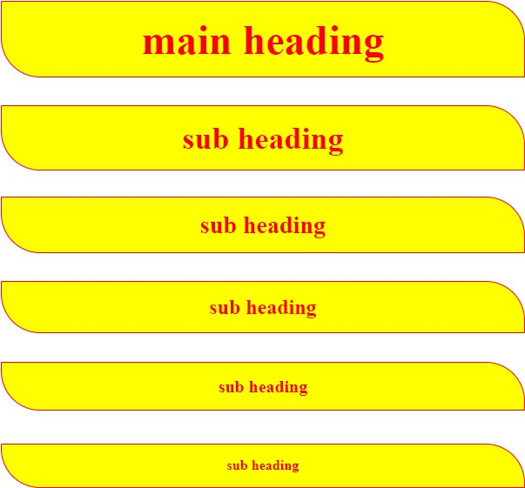

**PRACTICE PAPER**

1) How to apply internal styles to the web pages

2) write the Differences between external CSS and Internal CSS?

3) how to create Divisions in HTML

4) Explain Selectors in CSS?

5) Class selector should start with

6) ID Selector should start with

7) Differences Between Class selector and ID Selector?

8) How to create universal selector

9) Write the code for below application

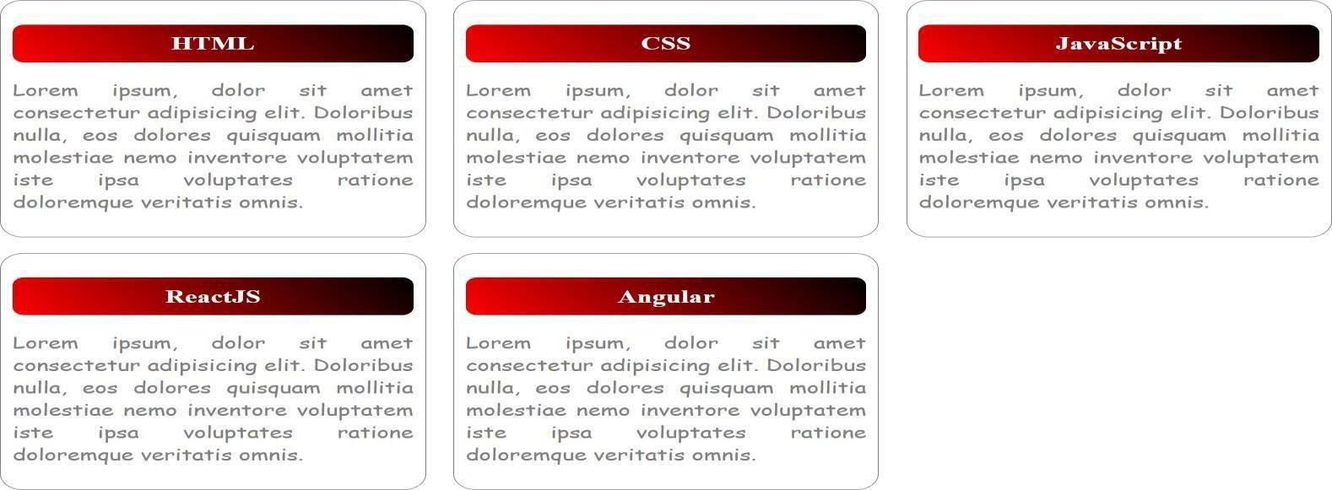

**PRACTICE PAPER**

1) How to Create Button and Write Basic Example

Ans:

2) Explain <span> tag in HTML?

Ans:

3) Are Button Span and img tags are inline (yes/no)

4) How to write inline CSS

5) In How Many ways we can apply CSS?

Ans:

6) Explain CSS Specificity?

Ans:

7) How to display images in HTML _

8) Is <img> tag paired tag? _

9) Write <img> tag attributes

Ans:

10) Explain hover in CSS? Ans:

11)write the code for below application

**Hyperlinks, FieldSet, Marquee, TextFormating Tags**



**PRACTICE PAPER**

1) How to create Hyper Links in HTML? Ans:

2) Write Attributes of Anchor Tag? Ans:

3) implement the below application with anchor tag Flipkart -> https:[//www.flipkart.com/](http://www.flipkart.com/) Amazon -> https:[//www.amazon.in/](http://www.amazon.in/)

AJIO -> https:/[/www.ajio.com/](http://www.ajio.com/) Myntra -> https:/[/www.myntra.com/](http://www.myntra.com/) Load above web sites in new tab

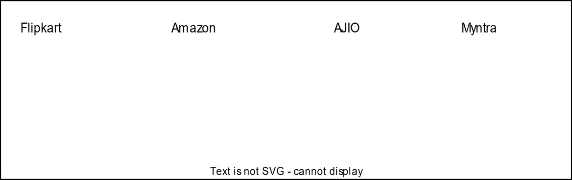

4) implement the below application with anchor tag

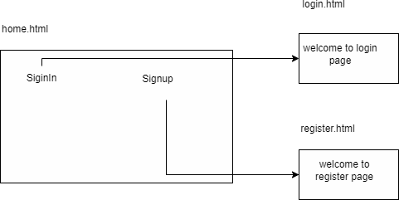

**PRACTICE PAPER**

1) Design the Below Application with field set and legend

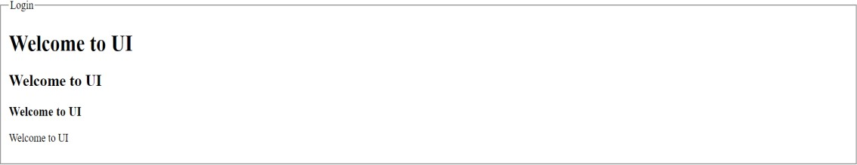

**PRACTICE PAPER**

1) which tag used to create tables

2) write the tags to create tables with diagram

Ans

3) write table attributes with explanation

Ans

4) write the code for below diagram in practice paper and execute in laptop

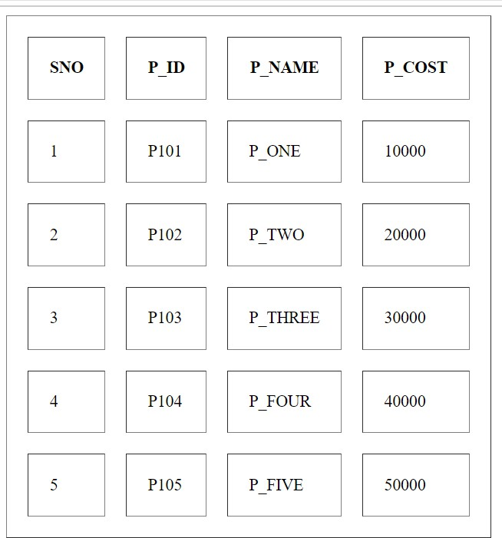

5) write the code for below diagram in practice paper and execute in laptop

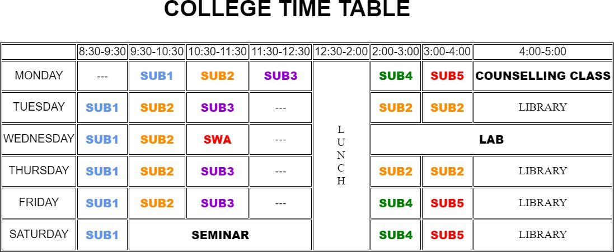

6) write the code for below diagram in practice paper and execute in laptop

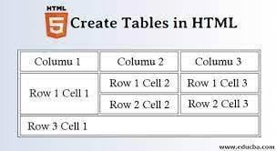

7) write the code for below diagram in practice paper and execute in laptop

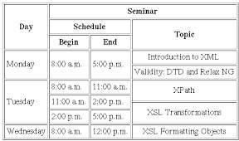

8) write the code for below diagram in practice paper and execute in laptop

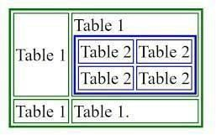

9) write the code for below diagram in practice paper and execute in laptop

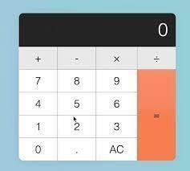

10)write the code for below diagram in practice paper and execute in laptop

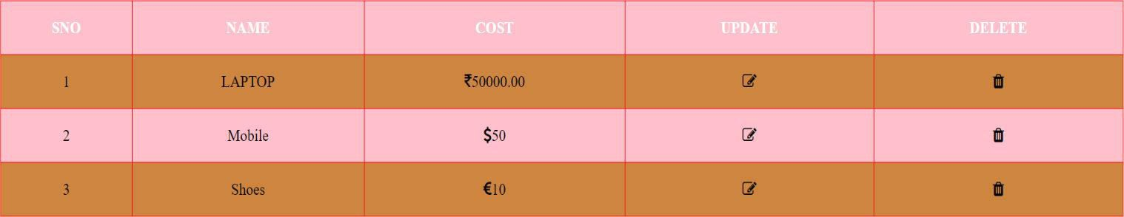

11)write few points related to font-awesome

12) cart symbol

13) trash symbol

14) edit symbol

15) rupee symbol

16) dollar symbol

17) user profile

18) how to use font-awesome

19) CDN Stands for

20) is Font Awesome CSS library?

**PRACTICE QUESTIONS**

) Types of Lists in HTML?

Ans:

2) Write the Syntax for Ordered List?

Ans:

3) Write the Attributes of Ordered List?

Ans:

4) Write the Syntax for Unordered List?

Ans:

5) Write the Unordered List Attributes?

Ans:

6) Write the Syntax for Definition List

Ans:

7) <dt></dt> stands for

8) <dd></dd> stands for

9) <li></li> stands for

10) <dl></dl> stands for

11) Write the code for below application and execute in laptop

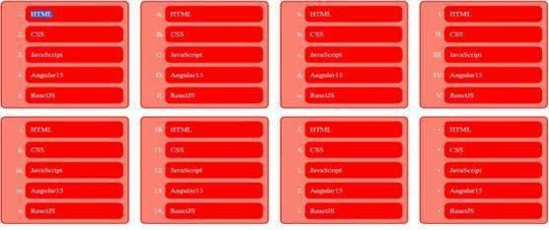

12) Write the code for below application and execute in laptop

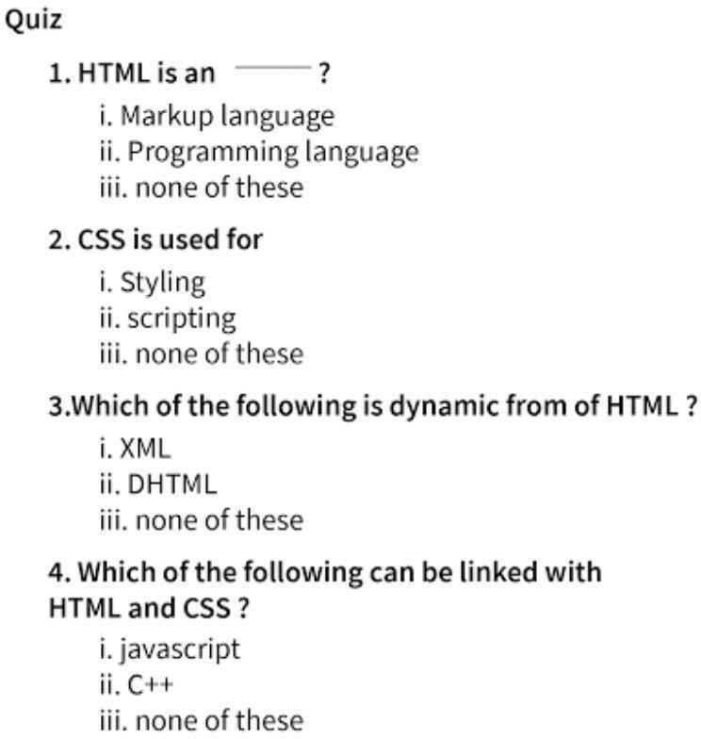

13) Write the code for below application and execute in laptop

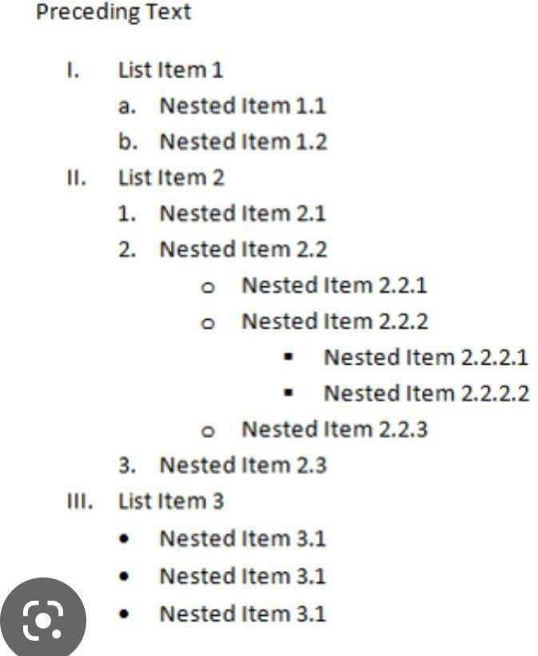

14) Write the code for below application and execute in laptop

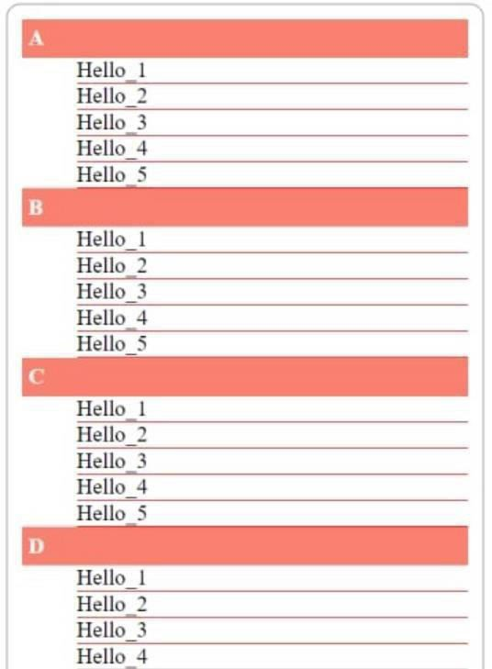

**PRACTICE PAPER**

1) How to create Forms in HTML

2) Write form attributes

3) Why placeholder attribute in <input></input> tag

4) How to create dropdown in Forms write basic example

5) How to create address field in HTML Forms

6) Single selection controls called as

7) Multi selection controls called as

8) implement the below form with text field

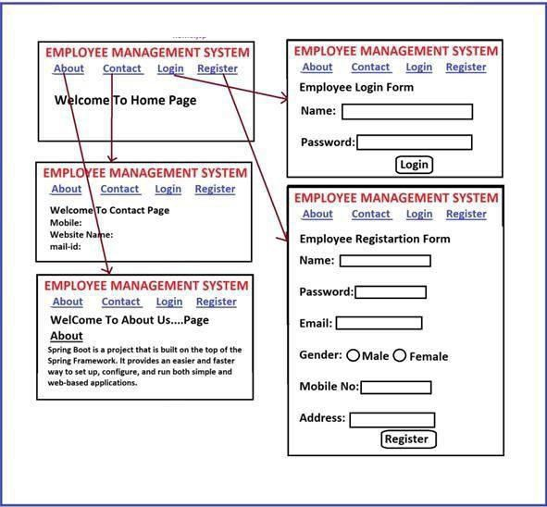

9) implement the below form

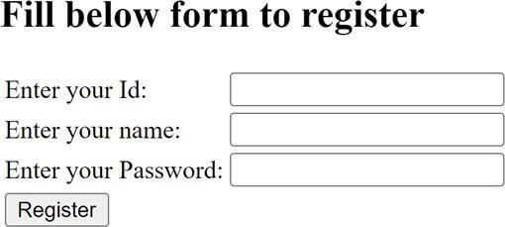

10) implement the below form

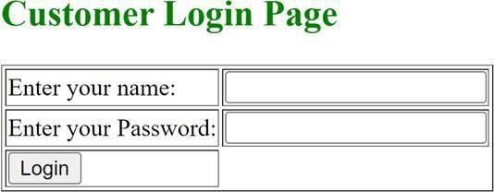

11) Write HTML code to get following text box?



12) Write HTML Code for following output



13) Write code for following output



14) Write Code for following output

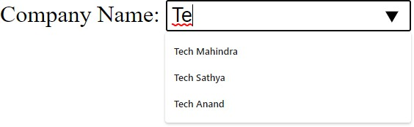

15) Write code for following output



16) Write HTML code to for following Output



17) Write HTML Code for following output



18) Write HTML code for following output

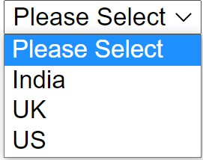

19) implement the below form

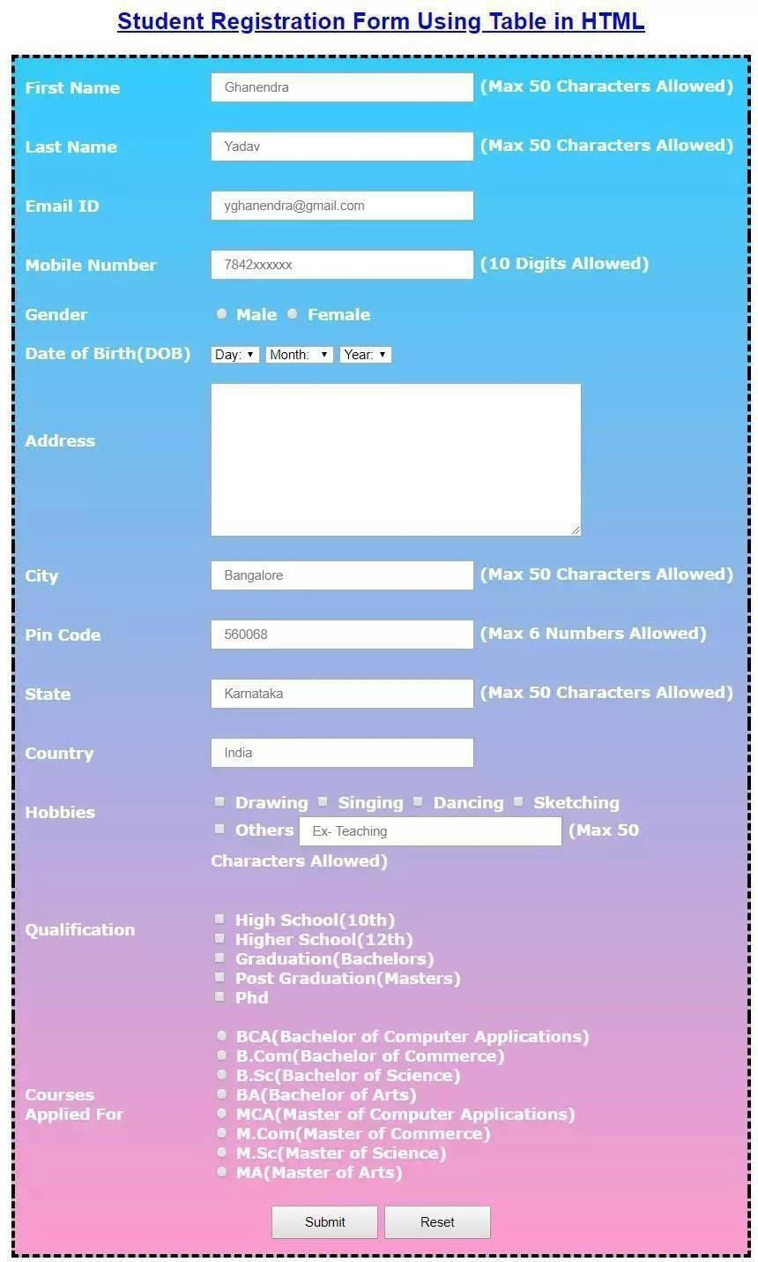

**PRACTICE PAPER**

1) Explain Positions in CSS?

2) What are the Differences Between Absolute and Relative Positions?

3) Implement The Below Application Absolute Position

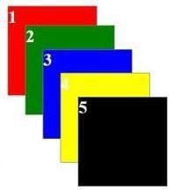

4) Implement the Below Application with CSS Relative Position



5) What is Z-Index in CSS?

6) Which one is the default position in CSS

7) How to display Element in center of webpage

Ans:

8) What is border-box in CSS?

**PRACTICE PAPER-1 (BASICS)**

1) What is JavaScript

2) Is JavaScript used to implement Forms Validations?

3) What is the Extension for JavaScript files

4) How to Execute JavaScript files

5) Which tag used to include JavaScript to HTML

6) Is JavaScript used to develop Dynamic web pages?

7) Explain types of web applications?

8) What are the differences between static web application and dynamic web application?

9) Write the Differences Between Programming Languages and Scripting

Languages?

10) Is JavaScript execution Synchronous? _

11) Is JavaScript Object Based Scripting Language? _

12) Write few Predefined objects provided by JavaScript?

13) How to manipulate DOM Elements

14) How to debug JavaScript application

15) How to get the Current Data

16) How to display Data on webpage?

17) How to display data on browser console?

18) How to display array in the form of table in browser console?

19) Is JavaScript Secured?

20) How to View the Page Source?

21) How to open the Browser console?

22) Are semi colons (;) mandatory in JavaScript?

23) Why Comments in JavaScript?

24) JavaScript supports how many types of Comments?

25) Write the Syntax for Single line Comments in JavaScript?

26) Write the Syntax for Multi line Comments in JavaScript?

27) Is JavaScript Compiler Based Scripting Language?

28) Is JavaScript Interpreter Based Scripting Language?

**PRACTICE PAPER**

**(variables)**

1) Why variables?

2) How to declare variables?

3) Write the Rules to declare variables?

4) What is datatype?

5) How many types of Datatypes?

6) What are the Differences Between Primitive datatype and non-primitive datatype?

7) Write the Primitive datatypes?

8) Write the non-primitive datatypes?

9) Write the JavaScript program Store value **100** to **x** variable Store value **200** to **y** variable

Find the addition of **x and y** variables and store to **z variable**

Print the **z variable**

10)Write the JavaScript Program

Store value **10** to **x** variable

Find the **square** of **x** variable and store result to **y variable**

Print **y variable**

11) What is string?

12) How to declare String in JavaScript?

13) Find the Result

var firstname=” ExcelR”;

var lastname=” EduTech”;

var fullname=firstname+” “+lastname;

document. Write(fullname);

o/p:

14) Find the Result

var sub=`fullstack`;

var msg=`welcome to ${sub}`;

document. write(msg);

o/p:

15) Write the few points related to backtick operator?

16) What are the Boolean values?

17) Write the Syntax for ternary operator?

18) 9>8>7? document. write(“java”): document. write(“dotnet”);

19)1<2<3? document. write(“java”): document. write(“dotnet”);

20)NaN Stands for

21)Write the Differences Between undefined and null?

22) What are the differences between == and === with examples?

23) let and const introduced in version

24) write the range of bigint datatype

25) bigint datatype introduced in version

26) bigint datatype suffix

27) how to hide identifiers

28) write the differences between var and let?

29) write few points related to const keyword with examples?

30) What is variable hoisting?

31) How to declare block in JavaScript

32) Find the Result 33) Find the Result 34) Find the Result

var x=100; let x=100; const x=100; var x= 200; let x=200; const x=200; document. Write (x); document. Write (x); document. write(x); o/p: o/p: o/p:

**PRACTICE PAPER**

1)How to represent arrays _

2)Index starts from _

3) How to access array elements

4) How to iterate array elements?

5) Write the for () loop Syntax?

6) Iterate following array with for loop

let arr1= [`Java`, `dotnet`, `ui`, `react`, `angular`];

7) Write the forEach () loop Syntax?

8) Iterate following array with forEach () loop

let arr1= [`Java`, `dotnet`, `ui`, `react`, `angular`];

9) Write the for of () loop syntax?

10) Iterate following array with for of () loop

let arr1= [`Java`, `dotnet`, `ui`, `react`, `angular`];

11) Write the if else condition syntax?

12) Find the Result

If(true) {

document. write(“java”);

} else {

Document. Write(“dotnet”);

}

o/p:

13) Write the switch cases syntax in javascript?

14) Write one basic example for switch case in javascript?

15) Find the Result

let arr1 = [10,20,30,40,50];

arr1[0]

arr1[4]

arr1[10]

arr1[-1]

arr1.at (0) arr1.at (-1) arr1.at (-5) arr1.at (-10)

1) What is function?

Ans:

**Practice Paper**

2)Set of statements called as

3)Are functions used to reuse business logic?

4)What are the types of functions?

5)Write the Syntax for function declaration?

6)Write the Syntax for function expression?

7) Write the Syntax for arrow functions?

8) Can I store function expression and arrow functions to variables?

9) How to represent arrow functions _

10) Arrow functions are introduced in _ version

11) How to read **data and write** from <input> tag

12) How to get the Reference of <input type=”text” id=” username”>

Ans

13)How to set the content to HTML Element

14)What are the differences between innerHTML and innerText in JavaScript?

Ans:

15) User Enters first name, Last name then they will click fullname. Now full name has to display in Input3

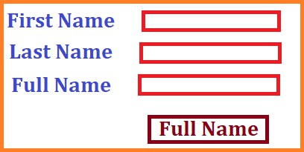

16) User Enter FirstName, Last Name Then when they click fullname then Full name display in h1 element

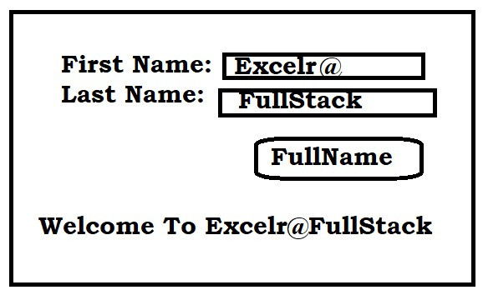

17) User Enter a, b values, then What ever Button they click that result has to Display in output area.

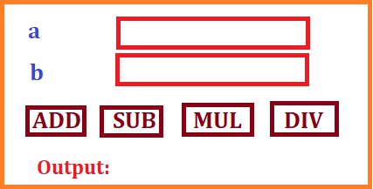

18) User Enter a, b values then they click on Button, now swap the numbers then display in next input controls

https://excelr.com/

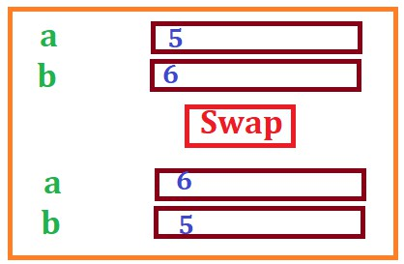

19) User Enter annual salary then They click on calculate button. Now monthly salary has to

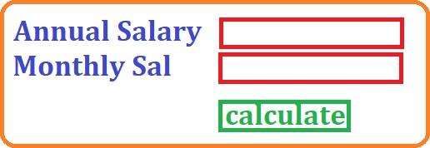

display in TextBox2

20) User Enter p value, q value

Then they click on button. Now product Has to display in input control 3

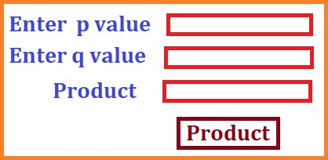

21) User Enters product name, cost, Quantity. Now if he clicks calculate button Then bill amount has to display in Input4

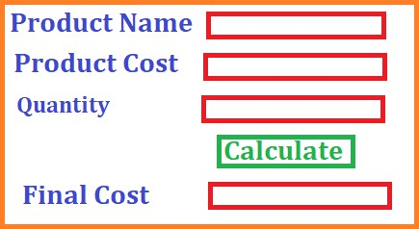

22) User Enter 3 subject marks, then if they click on total it has to display In Input4, if they click on Avg then Collect total from textbox4 and find Average then displays in Input5

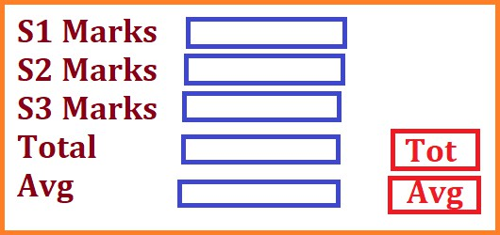

23) User Enter Loan Amount, Interest rate, time period. Now if they click on interest Amount It has to calculate interest amount and display in Input4, If they click on Final Amount then It has to display in Input5

24) User Enter Product name, Cost, gst %. Now if they click on GstAmt, GstAmt has to display in Input4. Now if they click on Final Cost then Productcost+gstAmt has to display in Input5.

25) write the answers for below

code

<script>

function func_one (param1, param2, param3) {

document. write (param1, param2, param3, "<br>");

}

func_one("ReactJS","NodeJS","MongoDB");

Ans:

func_one (100,200,300,400); Ans:

func_one (); Ans:

func_one(undefined,"Hello");

Ans:

func_one (null, null, null); Ans:

</script>

26) what is spread operator? Write few points

Ans:

27) how to represent spread operator

28) is spread operator released in ES6 version

29) write the rules to use spread operator?

Ans:

30) what are default parameters in functions?

Ans:

31) can we pass more than one default parameter (yes/no)?

32) will undefined overrides the default value (yes/no)?

33) will null overrides the default value (yes/no)?

34) write the program with function declaration, function expression and arrow

function

➢ name of the function is **“demo_func”**

➢ should display **“welcome to named functions”**

➢ call the **“demo_func”**

35)write the program with function declaration, function expression and arrow function

✓ name of the function is “demo_func”

✓ should contain following parameters

1)formal parameter with “param1”

2)default parameter with “param2” with value as “Hello”

3)spread operator with “param3”

✓ call the demo_func without any arguments (no data)

**36)** create the function declaration/function expression/arrow function should return number **“10”**

Ans:

**37)** create the function declaration/function expression/arrow function should return string **“ExcelR”**

Ans:

**38)** create the function declaration/function expression/arrow function should return Boolean “**true”**

Ans:

**39)** create the function declaration/function expression/arrow function should return **[100,200,300,400,500]**

Ans:

**40)** create the function declaration/function expression/arrow function should return **{sub_one: `ReactJS`, sub_two: `NodeJS`, sub_three: `MongoDB`}**

Ans:

41) function declaration/function expression/arrow function should return following array of objects

[{p_id:111, p_name:"p_one”, p_cost:10000},

{p_id:222, p_name:"p_two”, p_cost:20000},

{p_id:333, p_name:"three”, p_cost:30000},

{p_id:444, p_name:"p_four”, p_cost:40000},

{p_id:555, p_name:"p_five”, p_cost:50000}]

Display result in the form of a table

42) function should accept two parameters

If param1 and param2 are “admin” return true otherwise false

And apply ternary operator

43) function should accept one parameter i.e., number Return square of a

Number

44) function should accept one parameter i.e., number Return even / odd

45) function should accept one parameter i.e.; number Return prime number or not

46) function should accept three parameters

1) param1 is number

2) param2 also number

3) param3 is string (i.e., add / sub / mul / div)

4) return result based on 3rd parameter